***CLASS DIAGRAM***

First nafqeafvv

**Surgical**

**technologist**

**Surgeon**

**Technologist**

**Technician**

**Front desk**

**Staff**

**Nurse**

**Doctor**

**Specialty: string**

**Locations: string**

**Receptionist**

**Person**

**Title: string**

**First name: string**

**Last name**: **string**

**Birthdate: date**

**Gender: gender**

**Homeadderess: address**

**Phone: number**

**Staff**

**Joined: date**

**Education: string**

**Certificate: string**

**Language: string**

**Technical**

**Staff**

**Addministrative**

**Staff**

**Operation**

**Staff**

**Patient**

**Id: string{id}**

**Name: fullname**

**Gender: gender**

**Birthdate: date**

**Age: integer**

**Acception: date**

**Sickness: history**

**Prescription: string**

**Specialreduest: string**

**Department**

**Clinic**

**Name: string{id}**

**Address: address**

**Phone: phone**

***FLOWCHART FOR COMMUNITY CLINIC MANAGEMENT SYSTEM***

NEW PATIENT

REGISTRATIONS

PATIENT DISCHARGE

PATIENT PROGRESS

BED & ROOM ALLOCATION

INFORMATION ENTRY TO DATABASE

LOGIN PATIENT ID

DOCTOR ALLOCATION

ADVANCE FEES ENTRY

TEST & REPORTS ENTRY

CREATE RECORD ENTRY DATABASE

CREATE PATIENT ID

CREATE USERNAME & PASSWORD

PENDING FEES

***ZERO LEVEL DATAFLOW DIAGRAM***

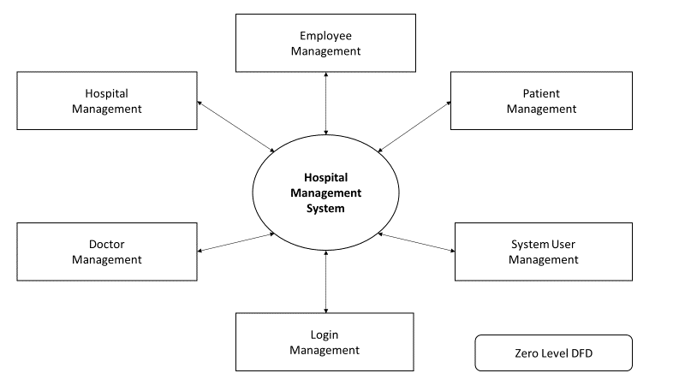

***FIRST LEVEL DATAFLOW DIAGRAM***

Employee

Management

Patient

Management

System User

Management

Login

Management

Zero Level DFD

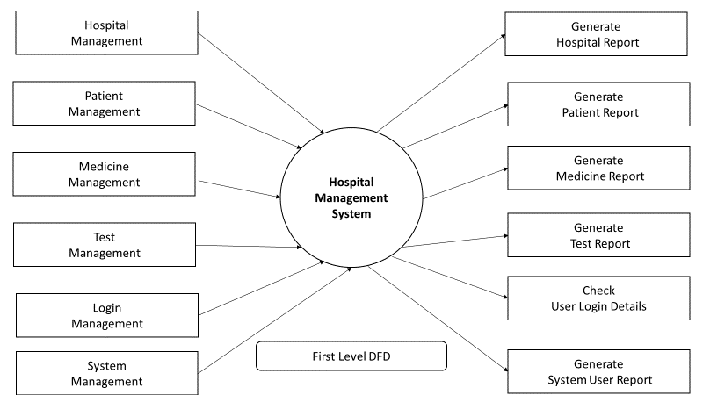

***SECOND LEVEL DATAFLOW DIAGRAM***

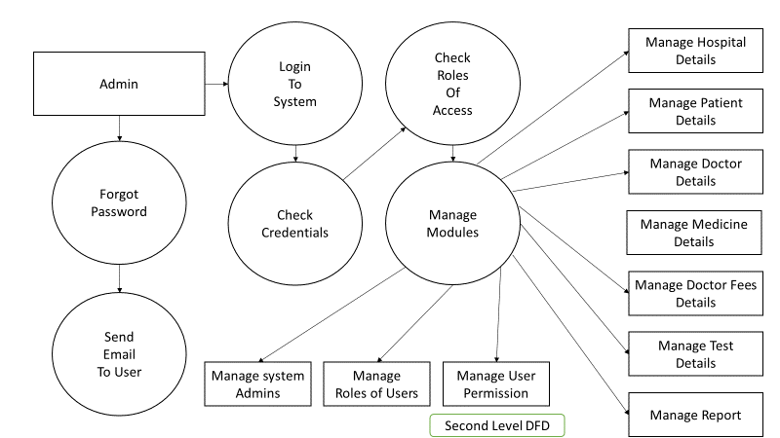

***USE CASE DIAGRAM***

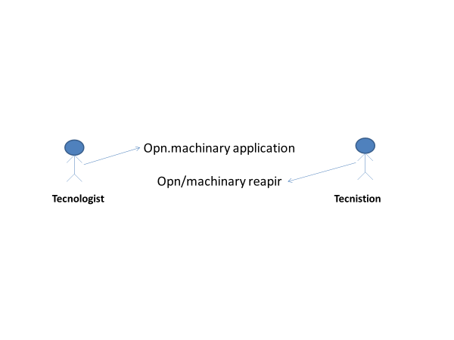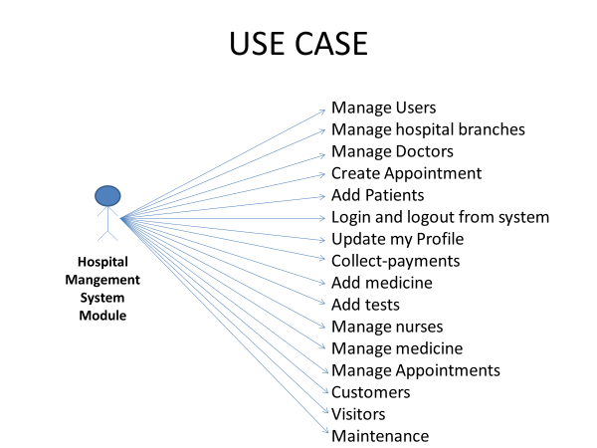

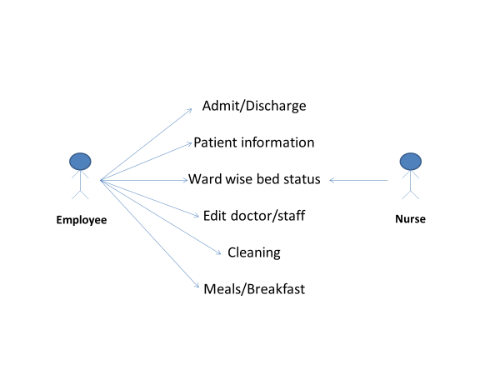

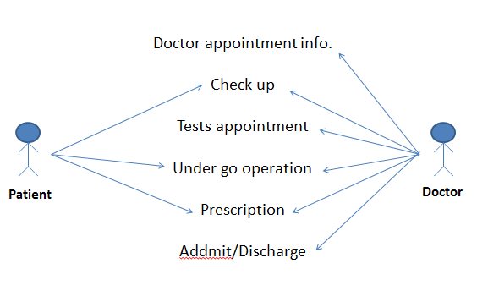

**ALGORITHM FOR COMMUNITY CLINIC MANAGEMENT SYSTEM (CCMS)**

1. *Start*
2. *Check Database Exist or none*
3. *If Exist then Go to Step 5*
4. *If Database setting none then Open Setting page for Input Setting Information*
5. *Open Login page*
6. *If Login information exist*
7. *Go to Step 10*
8. *Open new User Registration page*
9. *Allocate memory for new User Information*
10. *Enter Username & Password*
11. *Open Dashboard Page*
12. *Open Existing Patient*
13. *If not exist Go to Step 8*
14. *Open new Patient registration page*
15. *Allocate memory for new patient information*
16. *Enter information*
17. *Create unique patient id as its NID*
18. *Create username and password*
19. *Create entry to the database*
20. *Allocate doctor for the patient*
21. *Tests and reports entry*
22. *Initiate advance fees*
23. *Allocation of bed and room for patient*
24. *Patient health progress*
25. *Patient discharge*
26. *Pending fees and updating*
27. *End*

**ALGORITHM FOR ECG Data Analysis Part**

1. *Start*
2. *Ready Hardware Device [For Details go to Hardware design part]*
3. *Open Serial Port of Software*
4. *Select Baud and Port number as requirements*
5. *Start Button Click*
6. *If requirements are not fulfilled then go to STEP 5*
7. *Open Serial Port*
8. *Save to Database*
9. *End*